10. Display Status

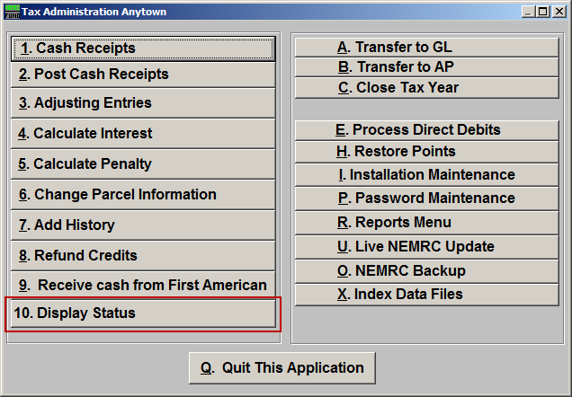
Click on “10. Display Status” from the Main Menu and the following window will appear:

Display Status

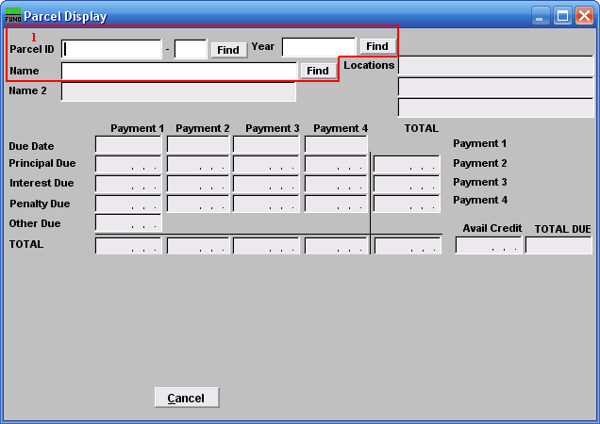
- Find: Enter a Parcel ID, Year, or Name, or click “Find” and select from the drop down menu.

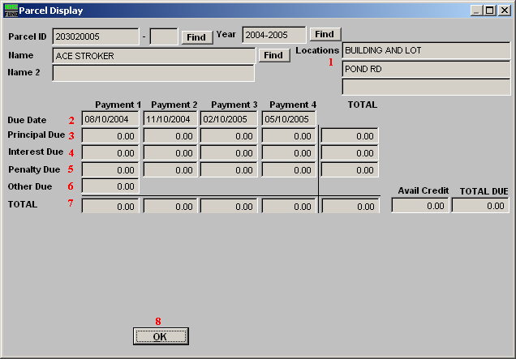
- Locations: These locations are carried forward from the Grand List transfer.

- Due Date: The dates for the defined number of payments will show on this line.

- Principal Due: This line displays the principal balances due for the defined number of payments.

- Interest Due: This line displays the interest balances due for the defined number of payments.

- Penalty Due: This line displays the penalty balances due for the defined number of payments.

- Other Due: This line shows any other amounts due on the account.

- Total: This line totals each due date defined values and grand totals plus displays available credit.

- OK: Click “OK” to save changes and return to the previous screen.

